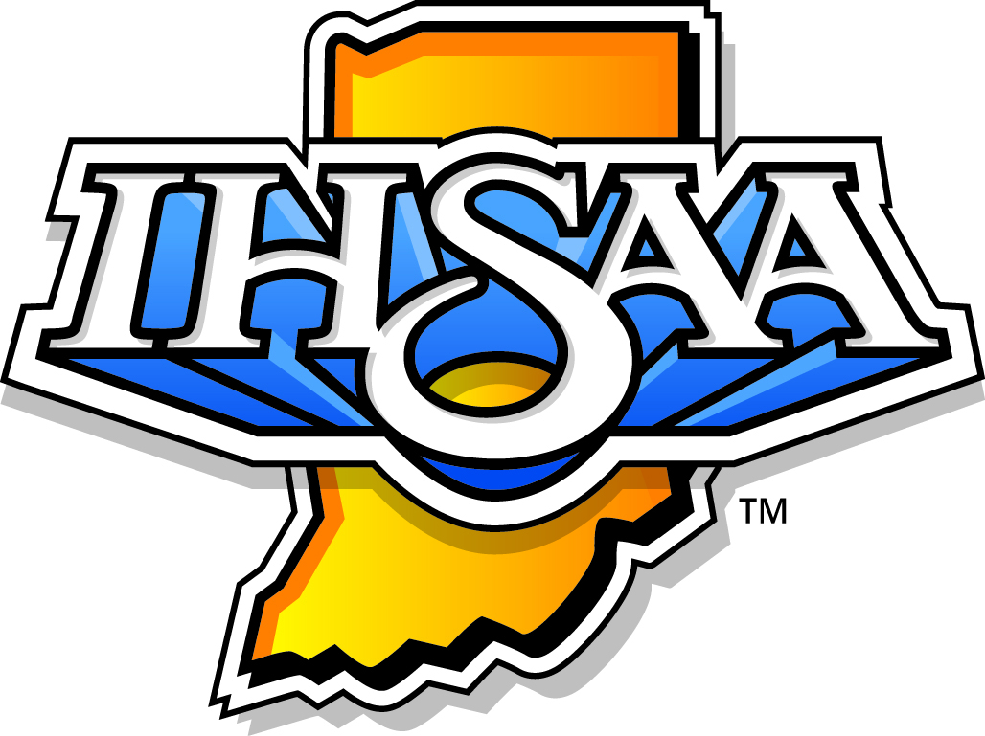

SPORTSMANSHIP – WHO IS RESPONSIBLE?
www.ihsaa.org

RESPONSIBILITIES OF BOARD OF EDUCATION
The Board of Education governs all levels of competition within school systems. With its support, your school administration can begin establishing the importance of the fundamentals of good sportsmanship in the minds of the entire school family and all those who associate with any of the activities of the school. In order for sports to serve a purpose in the educational system, students must obtain positive educational benefits from athletics such as: responsibility, self-discipline, sportsmanship, teamwork, work ethic, integrity and personal sacrifice for the good of others.
WHAT YOU CAN DO:
- Adopt policies that promote the ideals of good sportsmanship, ethics and integrity.
- Serve as a positive role model and expect the same from parents, fans, participants, coaches
and other school personnel.
- Support participants, coaches, school administrators and fans who display good
sportsmanship.
- Support the administration when it must remove someone from a game due to a lack of good
sportsmanship.
- Recognize the value of school activities as a vital part of education.
- Attend and enjoy school activities.

RESPONSIBILITIES OF THE COACH
The actions of the coach have a great deal to do with how sportsmanship is valued by the members of the team. In order for good sportsmanship to become a reality, the coach should:
- Always set a good example for members of the team and fans to follow.
- Instruct members of the team in regard to proper sportsmanship.
- Respect the judgment of contest officials.
- Display no behavior that could incite fans.
- Treat opposing coaches, participants and fans with respect.
- Shake hands with officials and opposing coaches in public.
- Develop consequences for those who do not abide by sportsmanship standards.

RESPONSIBILITIES OF THE STUDENT-ATHLETE
The responsibility of players with regards to sportsmanship is second in importance only to the coach. Because players are admired and respected, they can exert a great deal of influence over the actions and behaviors of spectators.
WHAT YOU CAN DO
- Treat opponents with the respect they deserve as guests and fellow human beings.
- Shake hands with opponents and wish them good luck before and after the contest.
- Exercise self-control at all times, accepting decisions and abiding by them.
- Respect the integrity and judgment of the officials. Never argue or make gestures indicating
the dislike of a decision.
- Accept both victory and defeat with pride and compassion, being neither boastful nor bitter.
- Congratulate opponents in a sincere manner following either victory or defeat.

RESPONSIBILITIES OF PARENTS
- Realize that a ticket is a privilege to observe a contest and support high school activities. It is
not a license to verbally assault anyone or act in an outrageous manner.
- Realize that athletics are part of the educational experience and that its benefits go beyond
the final score of the contest.
- Respect the decisions made by officials and learn the rules of the game to better understand
their decisions.
- Participate in positive cheers and refrain from encouraging those who take away from the
spirit of the contest.
- Respect and support the task of the coaches.
- Respect opponents as students, and acknowledge them for striving to do their best.
- Be a parent your child would be proud of! Be a fan, not a fanatic!

RESPONSIBILITIES OF STUDENT FANS
- Realize that a ticket is a privilege to observe a contest and support high school activities, not
a license to verbally assault others or be generally obnoxious.
- Know and demonstrate the fundamentals of sportsmanship.
- Respect, cooperate and respond enthusiastically to cheerleaders.
- Respect the property of the school and the authority of school officials.
- Stimulate desired crowd response using only positive cheers, signs and praise without
antagonizing or demeaning opponents.
- Show respect for an injured player when he/she is removed from the contest.
- Do not applaud errors by opponents or penalties inflicted upon them.
- Do not heckle, jeer or distract members of the opposing team. Respect opposing spirit
groups, fans, coaches and participants.
- Never criticize the players or coaches for the loss of the game.
- Respect yourself, your team, officials, coaches, opponents and fans.
- Refrain from using profanity, racial or sexual comments and intimidating language or actions
directed to others.

RESPONSIBILITY OF CONTEST OFFICIALS
The officials of any contest are impartial arbiters who are trained and perform to the best of their ability. Mistakes by all those involved in the contest are a part of the contest. We should not rationalize our own poor unsuccessful performance or behavior by placing responsibility on an official. The rule of GOOD SPORTSMANSHIP is to accept and abide by the decisions that are made.
WHAT OFFICIALS CAN DO:
- Accept the role of an official in an unassuming manner. Avoid showboating.
- Maintain confidence and poise, controlling the contest from start to finish.
- Know the rules thoroughly and abide by the established Code of Ethics.
- Publicly shake hands with coaches of both teams before an athletic contest.
- Never exhibit emotions or argue with participants, coaches and fans.
- Work cooperatively with fellow officials, scorers and time keepers for an efficient contest.
- Withdraw from the playing area without delay at half-time and at the end of the contest.
- When watching a game as a spectator, give the contest officials the same respect you expect
to receive when working a contest.

RESPONSIBILITIES OF THE MEDIA
- Promote the ideals and fundamentals of good sportsmanship.
- Do not give undue publicity to unsporting conduct.
- Report facts without demonstrating partiality.
- Refrain from making negative comments and about participants in the contest.
- Sponsor sportsmanship awards for players and coaches.

RESPONSIBILITIES OF SCHOOL ADMINISTRATORS
- Develop a program for teaching and promoting the ideals and fundamentals of good
sportsmanship within the school, the conference/league and the IHSAA.
- Provide appropriate supervisory personnel for each interscholastic athletic event.
- Support participants, coaches and fans whose team displays good sportsmanship.
- Recognize exemplary behavior and actively discourage undesirable conduct by participants,
coaches and fans.
- Attend events whenever possible and function as a role model—show good sportsmanship.
This includes communicating with spectators during an event as to what is acceptable and
unacceptable behavior.

